GLOBAL SUPPLY CHAIN RISK ANALYSIS
EDA • Excel • Tableau • Power BI

1. Executive Summary
This project presents an end-to-end analysis of global supply chain risk using Python-based Exploratory Data Analysis (EDA) and dashboarding in Excel, Tableau, and Power BI. The supplied EDA notebook works with 5,000 shipment records and 14 variables. The analysis examines shipment activity, transport modes, product categories, weather conditions, carrier reliability, distance, fuel price index, geopolitical risk, lead time, and shipment disruptions.
The dashboard views translate the analytical results into interactive and management-oriented visual reports. Across the supplied dashboard screenshots, the headline figures are 5,000 total shipments, 3,063 total disruptions, and an average lead time of about 19.36 days. The Power BI view also presents a disruption indicator of approximately 0.61, corresponding to the supplied disruption field's average in the EDA summary.

2. Project Objectives
- Understand the structure and quality of the global supply chain shipment dataset.
- Explore shipment patterns across transport modes, product categories, weather conditions, and origin ports.
- Study lead time in relation to distance, fuel price index, geopolitical risk, and disruptions.
- Examine carrier reliability across transport modes.
- Identify monthly shipment and disruption trends.
- Convert EDA findings into dashboard-based reporting using Excel, Tableau, and Power BI.
- Provide a consolidated view that can be used for supply chain monitoring and reporting.

3. Dataset Description
According to the supplied EDA notebook, the dataset contains 5,000 rows and 14 columns. The notebook checks the first, last, and random records, data types, descriptive statistics, null values, duplicate rows, unique values, grouped values, and sorted values.
Field | Type | Purpose
Shipment_ID | Object | Unique shipment identifier
Date | Object → Date | Shipment date; converted to datetime for monthly analysis
Origin_Port | Object | Shipment origin port
Destination_Port | Object | Shipment destination port
Transport_Mode | Object | Air, Rail, Road, or Sea transport
Product_Category | Object | Shipment product category
Distance_km | Float | Shipment distance in kilometres
Weight_MT | Float | Shipment weight in metric tonnes
Fuel_Price_Index | Float | Fuel price index associated with shipment
Geopolitical_Risk_Score | Float | Geopolitical risk measure
Weather_Condition | Object | Weather condition associated with shipment
Carrier_Reliability_Score | Float | Carrier reliability measure
Lead_Time_Days | Float | Shipment lead time in days
Disruption_Occurred | Integer | Binary disruption indicator (0/1)

3.1 Dataset Quality Checks
Check | Result from supplied EDA notebook
Rows × Columns | 5,000 × 14
Missing values | 0 across all 14 columns
Duplicate rows | 0
Product categories | 5 unique categories
Origin ports | 9 ports
Weather conditions | 5 categories
Date handling | Converted to datetime before monthly trend analysis

3.2 Descriptive Statistics
Variable | Mean | Std. Dev. | Minimum | Maximum
Distance_km | 7,704.06 | 4,199.69 | 500.17 | 14,995.91
Weight_MT | 246.25 | 142.52 | 1.03 | 499.75
Fuel_Price_Index | 2.85 | 0.96 | 1.20 | 4.50
Geopolitical_Risk_Score | 5.08 | 2.88 | 0.00 | 10.00
Carrier_Reliability_Score | 0.754 | 0.144 | 0.50 | 1.00
Lead_Time_Days | 19.36 | 31.41 | 0.50 | 236.39
Disruption_Occurred | 0.613 | 0.487 | 0 | 1
The lead-time distribution is notably variable: the mean is 19.36 days while the median is 8.25 days and the maximum is 236.39 days. This difference indicates that some shipments have substantially longer lead times than the central portion of the dataset.

4. Exploratory Data Analysis (Python)
The supplied notebook uses NumPy, Pandas, Matplotlib, and Seaborn. The workflow moves from data loading and inspection to quality checks, grouping, categorical exploration, visualization, relationship analysis, correlation analysis, and monthly trends.

4.1 EDA Visualizations Included
Visualization | Variables / Purpose
Shipments by Transport Mode | Distribution of shipments across Air, Rail, Road, and Sea
Shipments by Product Category | Shipment distribution across five product categories
Weather Condition Distribution | Shipment counts across Clear, Fog, Hurricane, Rain, and Storm
Carrier Reliability by Transport Mode | Boxplot comparing reliability scores across transport modes
Shipment Distance Distribution | Histogram/KDE showing distance distribution
Geopolitical Risk vs Lead Time | Scatterplot with disruption status
Fuel Price Index vs Lead Time | Scatterplot coloured by transport mode
Distance vs Lead Time | Scatterplot with disruption status
Correlation Heatmap | Correlation structure of numeric variables
Monthly Shipment Trend | Monthly shipment count
Monthly Disruption Trend | Monthly sum of disruption indicator

4.2 EDA Findings Supported by the Notebook
- The dataset contains 5,000 shipment records with no null values reported by the notebook.
- No duplicate rows were detected.
- The five product categories are Textiles, Automotive, Perishables, Electronics, and Pharmaceuticals.
- The five weather categories are Clear, Fog, Hurricane, Rain, and Storm.
- Origin-port counts are distributed across nine ports; Busan has the largest count in the notebook's value-count output (667), followed by Rotterdam (646) and Shanghai (644).
- The average lead time is 19.36 days, with a median of 8.25 days and a maximum of 236.39 days.
- The average disruption indicator is 0.6126, meaning the supplied binary field is 1 for approximately 61.26% of records.
- The notebook explicitly investigates relationships between lead time and geopolitical risk, fuel price index, and distance.

5. Excel Dashboard Analysis
The supplied Excel-style dashboard screenshot presents a compact management dashboard. It places KPI cards at the top and combines monthly trends, transport mode analysis, weather-related disruptions, product-category distribution, origin-port disruptions, and fuel price/lead-time analysis on a single page.
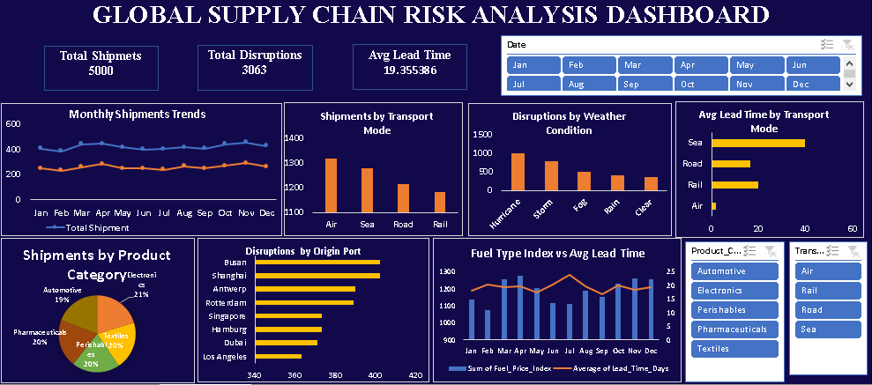

5.1 Excel Dashboard Components
- KPI cards: Total Shipments = 5,000; Total Disruptions = 3,063; Avg. Lead Time = 19.355386 days.
- Monthly Shipments Trends showing shipment activity and disruption activity across the year.
- Shipments by Transport Mode.
- Disruptions by Weather Condition.
- Average Lead Time by Transport Mode.
- Shipments by Product Category.
- Disruptions by Origin Port.
- Fuel Price Index vs Average Lead Time by month.
- Interactive month, transport mode, and product filters are shown in the supplied view.

6. Tableau Dashboard Analysis
The supplied Tableau screenshot presents the same supply-chain dataset in an interactive dashboard format. The design emphasizes filtering and visual comparison through KPI cards, slicer/filter controls, and multiple chart types.
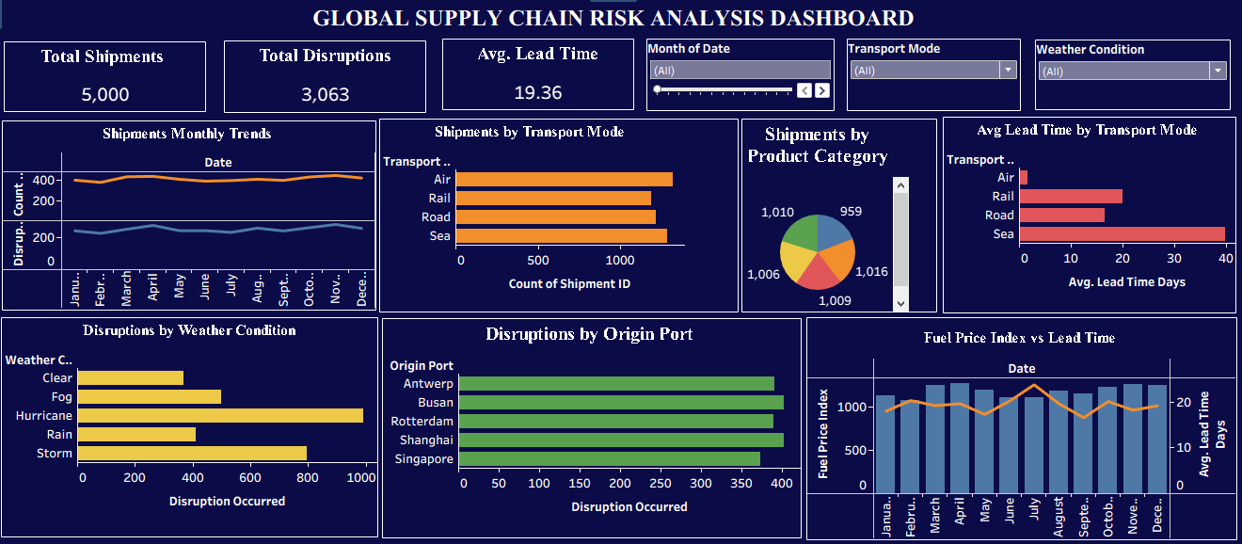

6.1 Tableau Dashboard Components
- KPI cards for total shipments, total disruptions, and average lead time.
- Date/month filtering and transport-mode filtering.
- Shipment trend by month.
- Shipment counts by transport mode.
- Shipment distribution by product category.
- Average lead time by transport mode.
- Disruptions by weather condition.
- Disruptions by origin port.
- Fuel Price Index versus Average Lead Time by month.
The screenshot shows 5,000 shipments, 3,063 disruptions, and an average lead time displayed as 19.36 days. These values are consistent with the EDA notebook's dataset size and lead-time average.

7. Power BI Dashboard Analysis
The supplied Power BI dashboard provides a business-intelligence style single-page view. It combines slicers, KPI cards, trend charts, category analysis, weather disruption analysis, origin-port analysis, fuel-price analysis, and transport-mode lead-time analysis.
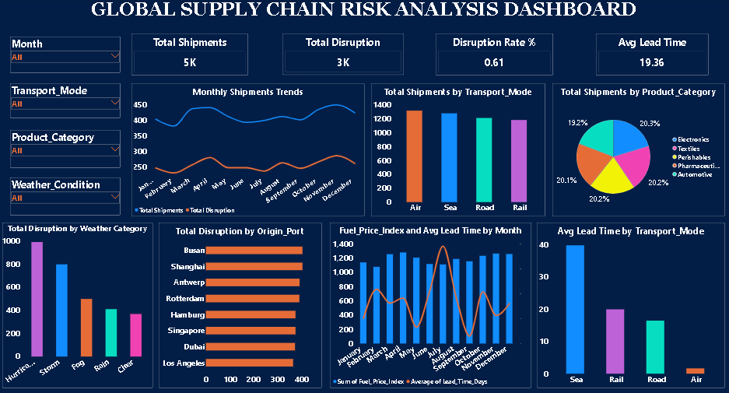

7.1 Power BI Dashboard Components
- Slicers for Month, Transport Mode, Product Category, and Weather Condition.
- KPI cards for Total Shipments, Total Disruption, Disruption Rate, and Avg Lead Time.
- Monthly Shipments Trends with shipment and disruption series.
- Total Shipments by Transport Mode.
- Total Shipments by Product Category.
- Total Disruption by Weather Category.
- Total Disruption by Origin Port.
- Fuel Price Index and Average Lead Time by month.
- Average Lead Time by Transport Mode.
The Power BI screenshot displays approximately 5K shipments, 3K disruptions, a disruption indicator of 0.61, and average lead time of 19.36 days.

8. EDA, Excel, Tableau and Power BI: Integrated Workflow
The project follows a clear analytical pipeline: raw shipment data → Python EDA → business-oriented dashboarding → visual communication. EDA is used to understand the data and relationships; Excel, Tableau, and Power BI present the findings in different interactive formats.
Stage | Primary Role | Main Output
Python EDA | Data inspection, quality checks, descriptive and relationship analysis | Statistical summaries and analytical charts
Excel | Familiar spreadsheet reporting and filtering | KPI + chart dashboard
Tableau | Interactive visual exploration | Filter-driven visual dashboard
Power BI | Business intelligence and KPI reporting | Interactive single-page BI dashboard

8.1 Visual Comparison
Area | Excel | Tableau | Power BI
KPIs | Present | Present | Present
Filters / slicers | Month and category/mode controls shown | Interactive filters shown | Multiple slicers shown
Trend analysis | Monthly shipment/disruption trend | Monthly trend | Monthly shipment/disruption trend
Transport analysis | Shipment count + lead time | Shipment count + lead time | Shipment count + lead time
Risk/disruption analysis | Weather + origin port | Weather + origin port | Weather + origin port
Fuel/lead-time view | Present | Present | Present
Overall focus | Spreadsheet reporting | Visual exploration | BI dashboard and KPI monitoring

9. Key Analytical Insights
The following points are directly supported by the supplied EDA notebook and/or visible dashboard elements. Where the dashboard and notebook use slightly different display precision, the notebook's numeric value is retained in the text.
- Scale: the analysis covers 5,000 shipments.
- Disruptions: 3,063 disruptions are displayed in the supplied dashboard views; the EDA binary disruption field has a mean of 0.6126.
- Lead time: the mean is 19.355386 days, with substantial variation and a maximum of 236.39 days.
- Data quality: the EDA notebook reports no missing values and zero duplicate rows.
- Origin ports: nine origin ports are present, with Busan having the highest shipment count in the notebook's value-count output.
- Weather: the dataset contains Clear, Fog, Hurricane, Rain, and Storm conditions, and the dashboards visualize disruption counts by weather category.
- Transport: Air, Rail, Road, and Sea are represented and are compared through shipment volume and lead-time visuals.
- Risk relationships: the EDA explicitly examines geopolitical risk, fuel price index, distance, and their relationship with lead time/disruption.
- Monthly monitoring: the project includes separate monthly shipment and monthly disruption trends, enabling time-based monitoring.

10. Limitations and Data Interpretation Notes
- The supplied EDA notebook contains analysis code and executed outputs, but the raw CSV/ZIP source file itself was not supplied as a separate file in this report package.
- The Excel, Tableau, and Power BI sections are based on the supplied dashboard screenshots; the screenshots do not expose every underlying formula, calculated field, or filter configuration.
- A disruption rate should be defined explicitly in the final implementation. The EDA binary field average is 0.6126, while dashboard displays may round this to 0.61.
- The large difference between average and median lead time indicates a highly variable lead-time distribution; average alone should therefore be interpreted with caution.
- Correlation or visual association should not be interpreted as proof of causation.
- The dashboard screenshots use rounded labels such as 5K and 3K, while the EDA notebook provides more precise values.

11. Future Scope
- Add a clearly defined disruption-rate measure to the dashboard.
- Create drill-through pages for origin port, destination port, transport mode, and product category.
- Add conditional formatting for high lead-time and high-risk shipments.
- Create a dedicated risk segmentation view combining geopolitical risk, carrier reliability, weather, and disruption.
- Add monthly and year-over-year comparisons if additional years of data become available.
- Add anomaly detection for unusually high lead-time shipments.
- Extend the analysis with predictive modeling only after clearly defining the prediction target and validating data quality.
- Document all calculated measures and dashboard formulas so the report can be reproduced.

12. Conclusion
The Global Supply Chain Risk Analysis project demonstrates a complete analytics workflow from data inspection and EDA to interactive business dashboards. The supplied notebook establishes the analytical foundation using Pandas, NumPy, Matplotlib, and Seaborn, while the Excel, Tableau, and Power BI views translate the results into accessible visual reporting.
The project covers shipment volume, disruptions, transport modes, product categories, weather conditions, origin ports, carrier reliability, distance, fuel price index, geopolitical risk, and lead time. The combined approach makes it possible to inspect both data quality and operational patterns while providing multiple dashboard formats for reporting and exploration.

13. Tools and Technologies Used
Tool / Technology | Purpose
Python | EDA and analytical workflow
Pandas | Data loading, cleaning checks, grouping and aggregation
NumPy | Numerical analysis support
Matplotlib | Base plotting
Seaborn | Statistical visualizations
Microsoft Excel | Spreadsheet dashboard and reporting
Tableau | Interactive visual analytics
Power BI | Interactive BI dashboard and KPI reporting

Appendix A – EDA Notebook Workflow
- Import NumPy, Pandas, Matplotlib, and Seaborn.
- Load the shipment dataset.
- Inspect first, last, and random records.
- Check shape, data types, and descriptive statistics.
- Check null values and duplicates.
- Analyze value counts, sorting, unique values, and grouped weather data.
- Create categorical and distribution visualizations.
- Analyze carrier reliability, distance, geopolitical risk, fuel price, and lead time.
- Create a correlation heatmap for numeric variables.
- Convert Date to datetime.
- Create monthly shipment and monthly disruption trends.

Appendix B – Source Files Used for This Report
- EDA ON GLOBAL SUPPLY CHAIN RISK DATA .ipynb
- Global supply chain risk .png
- tableau global supply .png
- power bi global supply .png

